FACULTY PROFILE
1 | Name |  | PILLI YEDUKONDALU |  |  |  | 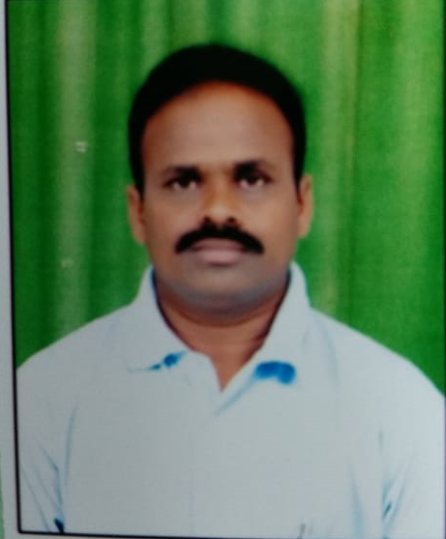
2 | Present position |  | Lecturer in Telugu  Since 01th 06- 2006
3 | Date of Birth and Age |  | 01-07-1973 ,49 years
4 | Caste and Nationality |  | SC, Indian
5 | Address Office  Residence |  | Department of Telugu  SVSSC Government Degree College Sullurpet, Tirupati District, A.P.  SS TOWERS, SHAR ROAD.  Sullurpet, Tirupati District, A.P.  Email: yedukondalusvkp@gmail , 9885874892
6 | Educational Qualifications
 | Name of the  Class/ Degree | Name of the  Institution |  | Name of the  Board/University | Year | Class |  | Specialization
 | (1) | (2) |  | (3) | (4) | (5) |  | (6)
 | SSC | ZPHS Tellabadu,Donakonda (m), Prakasam (Dt) |  | Board of Secondary Education, HYD | 1988 | Second |  | General
 | Intermediate | SSN College, Narasaraopet, Guntur(Dt). |  | Board of Intermediate Education, HYD | 1990 | Second |  | CEC
 | B.A | SSN College, Narasaraopet, Guntur(Dt). |  | ANUniversity,Guntur | 1993 | First |  | HPT(Special Telugu)
 | M.A  Telugu | University of Hyderabad |  | University of Hyderabad | 1996-98 | First |  | Telugu
 | M.Phil | University of Hyderabad |  | University of Hyderabad | 2000 | Khaki Bathukulu Navala samagra pariseelana
 | UGC NET | UGC |  | Delhi | 2000 | Telugu
The particulars above mentioned are true and correct to the best of my knowledge and belief.

Sullurpet, 14-11-2022
(P.YEDUKONDALU)

